AIR QUALITY INDEX

CLASSIFICATION USING ML

GitHub Link:
https://github.com/ManojKumarR4943/ManojKumarR_1BO23IS018_Project7_AQI_Classification

Introduction
Air pollution is one of the major environmental challenges affecting human health and ecosystems. The Air Quality Index (AQI) is a standardized measure used to indicate the level of air pollution. It helps people understand how polluted the air is and the associated health risks.
This project aims to use machine learning techniques to classify air quality levels based on pollutant concentrations. By predicting AQI categories, we can support environmental monitoring and decision-making.

Problem Statement
The objective of this project is to classify air quality into different categories using machine learning.
Input Features:
- PM2.5
- PM10
- NO2
- SO2
- CO
- O3
Target Variable:
- AQI_Category
Expected Outcome:
- Predict the AQI category accurately based on pollutant values.

Dataset Description
The dataset used in this project is obtained from Kaggle. It contains air quality data collected from different locations.
Key Features:
- PM2.5: Fine particulate matter
- PM10: Coarse particulate matter
- NO2: Nitrogen dioxide
- SO2: Sulfur dioxide
- CO: Carbon monoxide
- O3: Ozone
Target:
- AQI_Category (e.g., Good, Moderate, Poor, etc.)

Exploratory Data Analysis
Exploratory Data Analysis was performed to understand the dataset and relationships between variables.
- A correlation heatmap was used to visualize relationships between pollutants.
- A distribution graph was used to analyze the number of samples in each AQI category.
These visualizations help in understanding data patterns and feature importance.

Methodology

Data Preprocessing
- Missing values were handled using mean imputation
- Relevant features were selected

Feature Scaling
- Standard Scaler was used to normalize the data

Dimensionality Reduction
- Principal Component Analysis (PCA) was applied
- Reduced features to 3 components

Machine Learning Algorithm
- Nearest Centroid Classifier (NCC) was used

Model Training and Validation
- Dataset split into 80% training and 20% testing

Evaluation Metric
- Accuracy score was used to evaluate performance

Results and Evaluation
The model was successfully trained and tested.
Accuracy Achieved:
91.84%
This indicates that the model performs well in predicting AQI categories.

Discussion
The model achieved high accuracy, showing that PCA and NCC are effective for this classification problem. PCA helped in reducing dimensionality while preserving important information.
However, performance may vary depending on dataset size and quality.

Applications

• Air pollution monitoring systems
• Smart city development
• Health advisory systems
• Environmental research

Conclusion
This project successfully demonstrates the use of machine learning for air quality classification. The combination of PCA and Nearest Centroid Classifier resulted in good accuracy and efficient computation.
The model can be further improved using advanced algorithms and larger datasets.

References

• Kaggle AQI Dataset
• Scikit-learn Documentation
• Machine Learning textbooks and online resources

Screenshots and Results


Figure 1: Backend Code

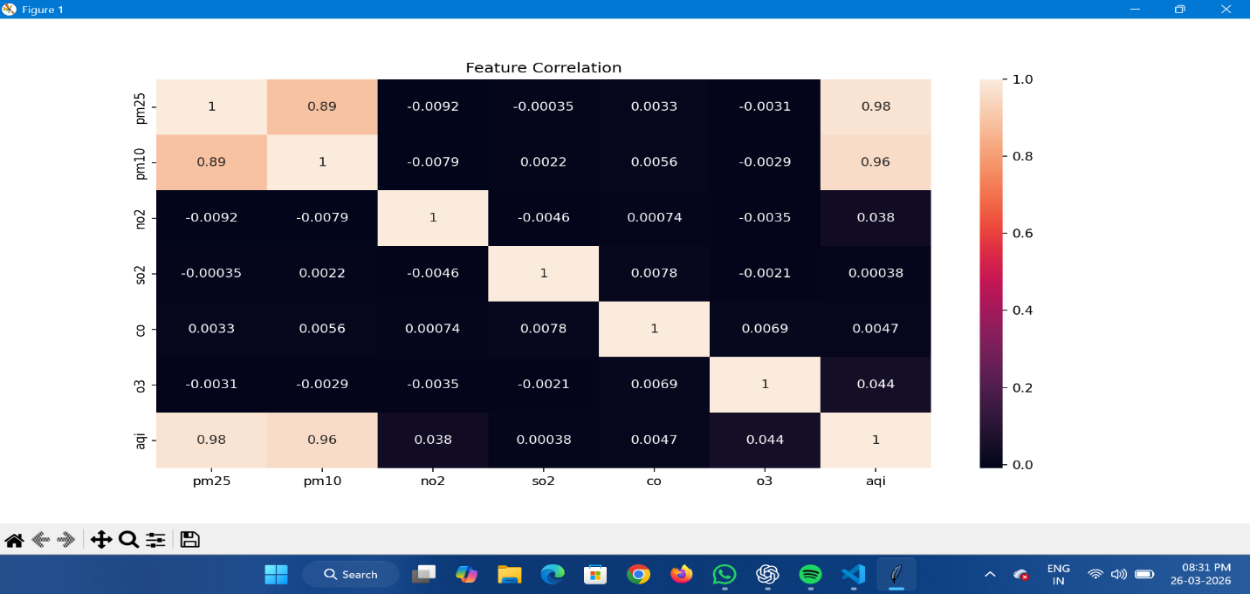
Figure 2: AQI Classification with Graph

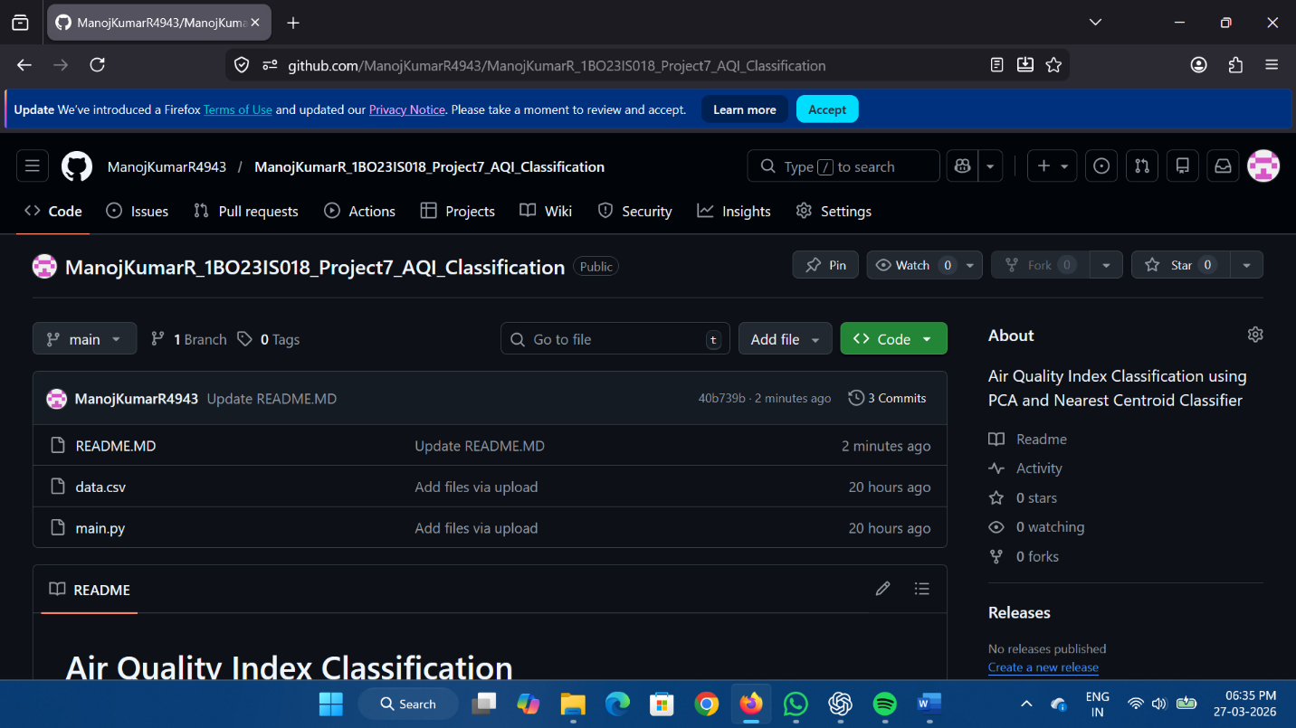
Figure 3: GitHub Repository

